U-easytech STM32F0-MC-V48A10/UET

STM32F0-MC-V48A10/UET motor control kit

Description:
The STM32F0-MC-V48A10/UET motor control kit consists of four parts: main control board, drive board, a BLDC motor and a JLINK debugger. The main board with 2.4’TFT LCD is based on ST MCU STM32F051R8T6. The motor kit can be used to drive a PMSM motor or a BLDC motor. With the JTAG interface you can use debugger STLINKIII or JLINK test your program.

Features:
- MCU: STM32F051R8T6, 32BIT ARM CORTEX-M3
- With power input DC 18v~24V, typical 24V
- power drive: 300W
- Typical configure: 24V BLDC with HALL SENSOR
- With hall connector, encoder connector and UVW connector
- sin wave or square wave drive
- one shunt current sampling
- easy human interface: 2.4’ TFT LCD, 5 user keys, 4 LEDs, RXD TXD connector or DA channel output
- support BLDC, PMSM or ACIM motor control
- With rich examples. With ST FOC V3.3 examples and other easy examples.

Order NO: STM32F0-MC-V48A10/UET
Photo:

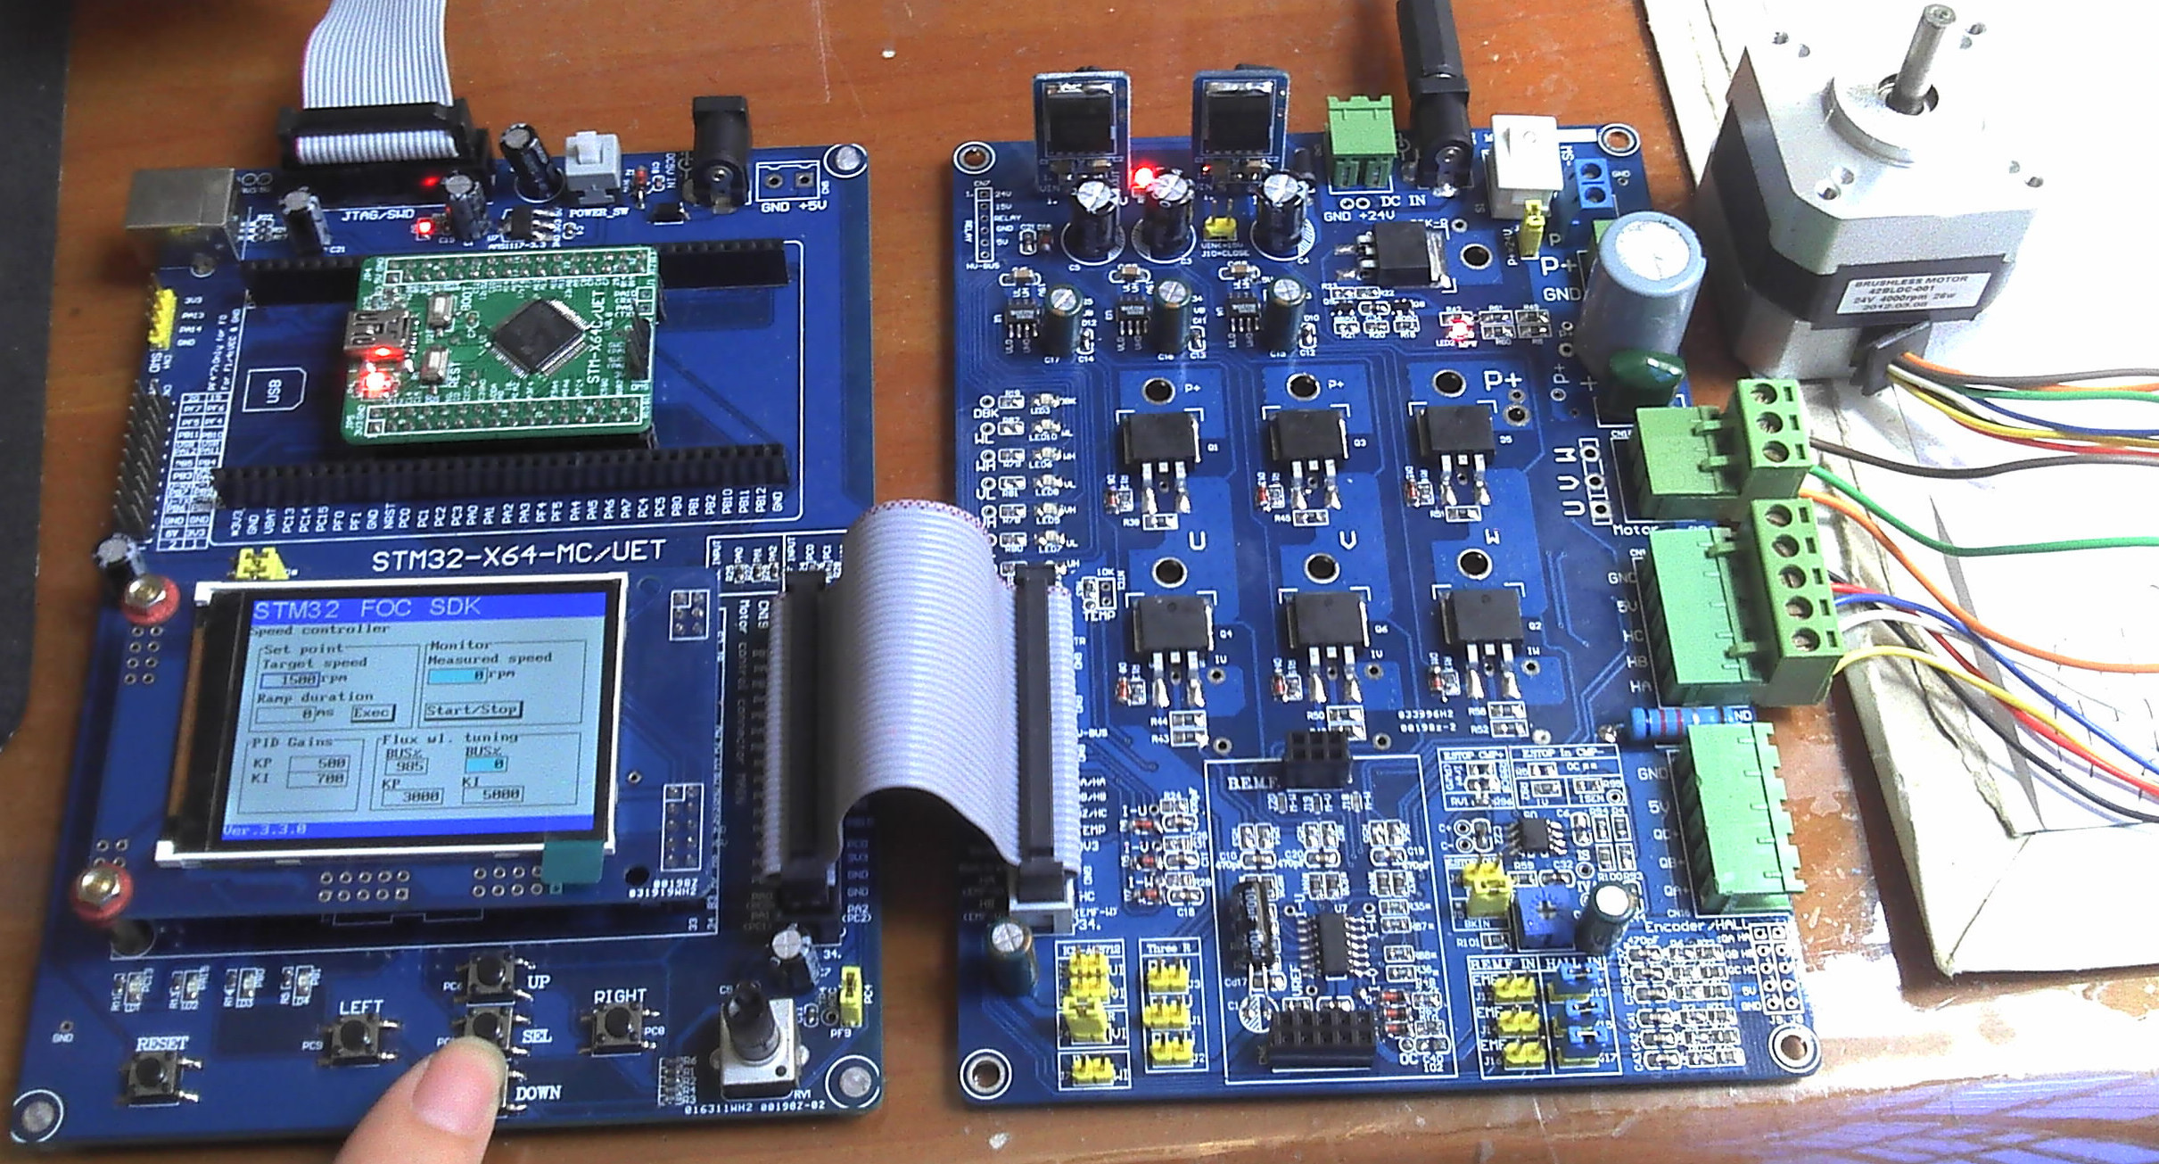

U-easytech STM32F0-MC-V48A10/UET

STM32F0-MC-V48A10/UET 核心板

简介:
STM32F0-MC-V48A10/UET 电机控制套件含四部分：主控制板、驱动板、一个BLDC电机和一个JLINK调试器。主控板上自带一个2.4‘TFT LCD，采用STM32F051R8T6芯片。开发套件可以驱动PMSM电机或BLDC电机。用户可能过STLINK或JLINK下载程序并进行调试运行。

特点:
- 采用32位CORTEXM0内核的CPU：STM32F051R8T6
- 采用核心板+主控底板+功率板结构，方便调试与维修
- 电压输入：DC 12V～48V,标配24V电源
- 驱动功率：300W
- 典型配置： 24 V BLDC 带120度HALL 传感器
- HALL输入、光电编码器输入，反电动势侦测，多种有/无传感器控制方式
- 120º方波、180º正弦波控制方式，FOC矢量控制方式
- 单电阻电流检测，过流停车保护
- 方便的人机界面：TFT液晶显示、5按键、电位器、4个LED灯、串行通信接口
- 支持BLDC、PMSM、ACIM（三相交流异步）电机控制
- 例程非常丰富，包括自编的以源码方式提供的进阶式的例程，还有移植好ST FOC PMSM V3.3电机库例程。

订单编号：
- STM32F0-MC-V48A10/UET

