U-easytech STM32F4-MCD-IPM30/UET

STM32F4-MCD-IPM30/UET motor control kit

Description:
The STM32F4-MCD-IPM30/UET motor control kit consists of seven parts: main control board, two drive boards, a PMSM motor, a BLDC motor a JLINK debugger and two CDs. The main board with 2.8’TFT LCD is based on ST MCU stm32f407zgt6. The drive board is mainly using IPM module to drive a PMSM motor or a BLDC motor. With the JTAG interface you can use debugger STLINKIII or JLINK test your program.

Features:
- MCU: STM32F407ZGT6, 32BIT ARM CORTEX-M4
- With power input DC 18v~300V, typical 24V
- Large power drive: 600V 2KW IPM module
- Typical configure: 24V PMSM with 1000 pulses encoder
- Typical configure: 24V BLDC with HALL
- With hall connector, encoder connector and UVW connector
- sin wave or square wave drive
- three shunt current sampling
- easy human interface: 2.8’ TFT LCD, 6 user keys, 4 LEDs, RXD TXD connector or DA channel output
- support BLDC, PMSM or ACIM motor control
- With rich examples. With ST FOC V3.2 examples and other easy examples.

Order NO: STM32F4-MCD-IPM30/UET
Photo:

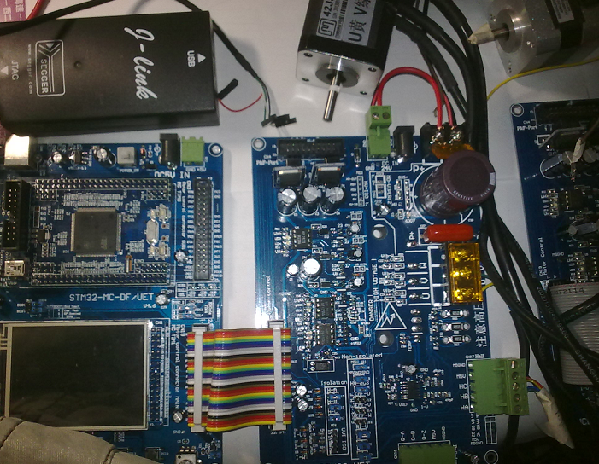

U-easytech STM32F4-MCD-IPM30/UET

STM32F4-MCD-IPM30/UET 核心板

简介:
STM32F4-MCD-IPM30/UET 电机控制套件包含七部分：主控制板、两个驱动板、一个PMSM电机，一个BLDC电机、一个JLINK调试器和两张光盘。主控板上自带一个2.8‘TFT LCD，采用STM32F407ZGT6芯片。驱动板主要采用进口IPM模块驱动电机。用户可能过STLINK或JLINK下载程序并进行调试运行。

特点:
- 采用32位CORTEXM4内核的CPU：STM32F407ZGT6
- 采用核心板+主控底板+功率板结构，方便调试与维修
- 宽电压输入：DC 18V～300V,标配24V电源
- 大功率驱动：配置600V 2KW IPM功率模块，
- 典型配置： 24V PMSM 带HALL 及1000线编码器
- 典型配置：24V BLDC 带HALL
- HALL输入、光电编码器输入，反电动势侦测，多种有/无传感器控制方式
- 120º方波、180º正弦波控制方式，FOC矢量控制方式
- 三电阻电流检测，过流停车保护（全隔离霍尔电流检测方式可选配）
- 方便的人机界面：TFT液晶显示、6按键、电位器、4个LED灯、串行通信接口
- 双电机控制接口，支持BLDC、PMSM、ACIM（三相交流异步）电机控制
- 例程非常丰富，包括自编的以源码方式提供的进阶式的例程，还有移植好ST V3.2电机库例程。（本套件基本兼容ST官方双电机控制板）

订单编号：
- STM32F4-MCD-IPM30/UET

