U-easytech STM32-X64-MC-05D/UET

STM32-X64-MC-05D/UET BOARD

Description:
The STM32-X64-MC-05D/UET board has been designed as a complete demonstration and development platform for the ARM cortex-M0 core-based STM32F051R8T6 microcontroller. The kits consist of three parts: STM32F0DISCOREY, a baseboard and a 2.4’TFT LCD. The discovery features one I2Cs, two SPIs, two USARTs, one 12-bit 16 channels ADCs, one channel DAC, internal 8-KByte Data SRAM and 64-KByte Flash, JTAG SWD mode debugging support. This evaluation board can be used as the reference design for user application development but it is not considered as a final application. With the SWD interface you can use debugger STLINKIII or JLINKV8 to test your program.

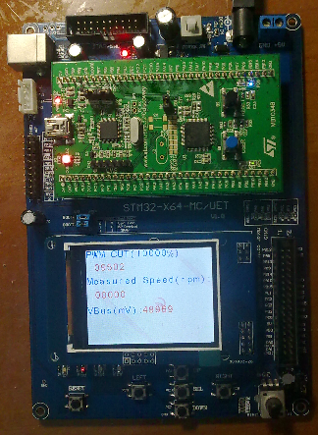
Features:
- MCU: STM32F051R8T6 (64pin)
- Core work at up to 48M frequency
- 64KB Flash and 8KB RAM
- l 2.4’ TFT LCD
- 4 User Leds, 5 User Keys
- 1 Power Key, 1 Reset Key
- 1 Power Led
- 1 DV 5V power interface
- 1 I2C EEPROM 24C02
- 1 SPI SD card interface
- 1 AD channel with Pointer
- l RTC with backup battery interface
- With motor control connector
- l JTAG Debug port
- l ALL I/O expansion
Order NO: STM32-X64-MC-05D /UET
System description：
4 User Ledss
Rower Key
STM32F051R8T6
Discovery board
DV 5V
USB Power
SWD port
AD Pointer
Reset Key
5 user keys
I2C eeprom
Boot choose
Motor control port
2.4 LCD
JTAG PORT
All IO pin
Power Led
SPI SD card

U-easytech STM32-X64-MC-05D/UET

STM32-X64-MC-05D/UET 开发板

简介:
STM32-X64-MC-05D/UET开发板是一块基于CORTEX-M0内核的STM32F051R8T6微处理器的开发平台。它由三部分组成：一个DISCOVERY，一个底板和一个2.4‘TFT LCD。STM32F051R8T6有1个I2C,2个SPI,2个USART, 1个12位16通道ADC转换器，1个12位 DAC转换器，内部有8KB的Data SRAM，64KB的FLASH,支持JTAG SWD模式调试。此评估平台可作为用户应用开发时做参考，而未作最终产品应用考虑。用户可通过SWD用STLINK或JLINK仿真下载程序。

特点:
- CPU:STM32F051R8T6 (64pin)
- 最大工作频率：48M
- 64K FLASH,8K RAM
- 一个2.4 TFT 液晶
- 4个用户指示灯，5个用户按键
- 1个电源开关，一个复位键
- 一个电源指示灯
- 一个DV5V输入接口
- 一个24C02 存储芯片
- 一个AD电位器
- 电池接口
- 电机控制接口
- 一个SPI SD卡接口
- 一个SWD下载口
- 所有IO引出

订单编号: STM32-X64-MC-05D /UET

