U-easytech STM3217V-CRE/UET

STM3217V-CRE/UET BOARD

Description:
The STM3217V-CRE/UET board has been designed as a complete demonstration and development platform for the ARM cortex-M3 core-based STM32F107VCT6 microcontroller. It features one I2Cs, three SPIs, five USARTs, two CANs, two 12-bit ADCs, two 12-bit DACs, internal 64-KByte Data SRAM and 256-KByte Flash, USB FS, JTAG debugging support. This evaluation board can be used as the reference design for user application development but it is not considered as a final application. With the JTAG interface you can use debugger STLINKIII or JLINKV8 to test your program.

Features:
- MCU: STM32F107VCT6 (100pin)
- Core work at up to 72M frequency
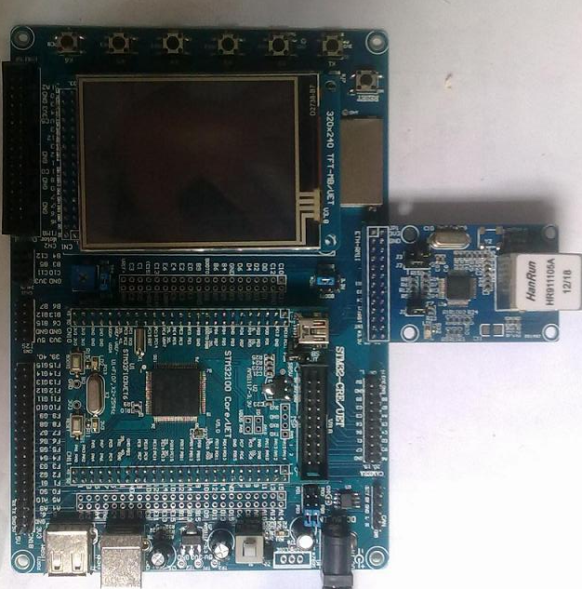
- 256KB Flash and 64KB RAM
- USB Device、SDIO interface
- l 2.8’ TFT LCD
- 1 CAN channel port
- 4 User Leds, 6 User Keys
- 1 Power Key, 1 Reset Key
- 1 Power Led
- 1 DV 5V power interface
- 1 I2C EEPROM 24C02
- 1 SPI FLASH AT45DB161
- 1 AD channel with Pointer
- l RTC with backup battery interface
- l JTAG Debug port
- l ALL I/O expansion

Order NO: STM3217V-CRE/UET
System description：

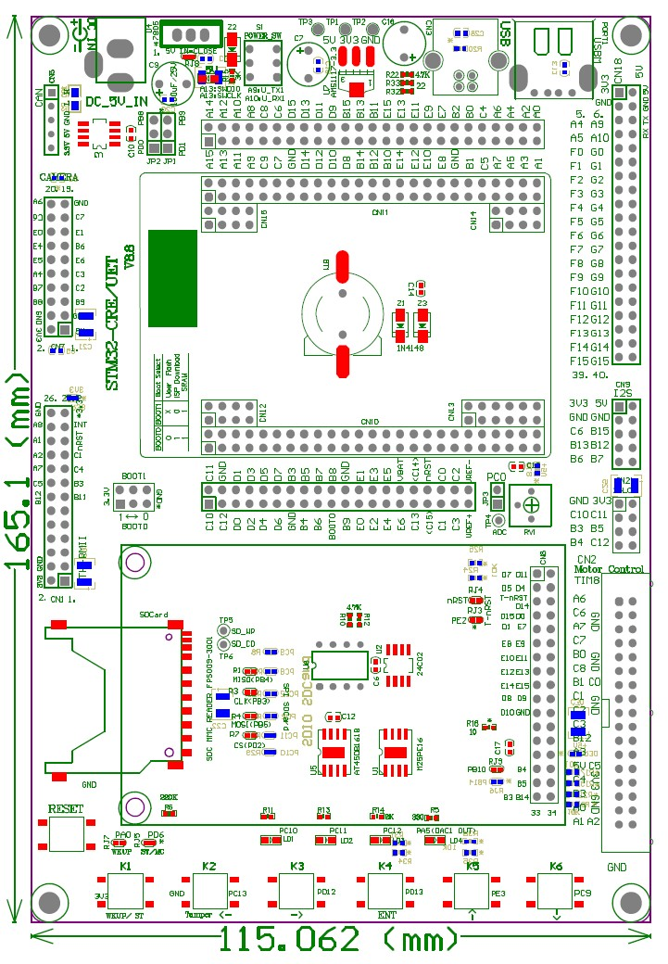
4 User Ledss
Reset Key
6 User Keys
TFT LCD
& touch
SPI or SDIO interface
SPI Flash
AT45DB/M25P
I2S interface
Boot SW Jump
DC 5V IN
Camera for F2/F4 CPU
Ethernet for F2/F4/F107
ADC Pointer
CAN chip
CAN interface
24L01 CN
DIP/SOP
MC control
interface

nRF24L01
interface
Part GPIOs
Back-up
Battery
STM32F107VCT6
CORE BOARD

Power Led
JTAG CN
Two kinds
Interface
Of USB

Power Key

U-easytech STM3217V-CRE/UET

STM3217V-CRE/UET 开发板

简介:
STM3217V-CRE/UET开发板是一块基于CORTEX-M3内核的STM32F107VCT6微处理器的开发平台。STM32F107VCT6 有1个I2C,3个SPI,5个USART,2路CAN,2个12位ADC转换器，2个12位DAC转换器，内部有64KB的Data SRAM，256KB的FLASH,支持USB FS和JTAG调试。此评估平台可作为用户应用开发时做参考，而未作最终产品应用考虑。用户可通过JTAG用STLINK或JLINK仿真下载程序。

特点:
- CPU:STM32F107VCT6 (100pin)
- 最大工作频率：72M
- 256K FLASH,64K RAM
- 具有USB 从设备接口和SDIO接口
- 一个2.8 TFT 液晶
- 一路CAN通道接口
- 4个用户指示灯，6个用户按键
- 1个电源开关，一个复位键
- 一个电源指示灯
- 一个DV5V输入接口
- 一个24C02 存储芯片
- 一个SPI FLASH AT45DB161
- 一个AD电位器
- 电池接口
- 一个JTAG口
- 所有IO引出

订单编号: STM3217V-CRE/UET

