U-easytech STM3237V-CRE/UET

STM3237V-CRE/UET BOARD

Description:
The STM3237V-CRE/UET board has been designed as a complete demonstration and development platform for the ARM cortex-M4 core-based STM32F373VCT6 microcontroller. It features two I2Cs, two SPIs, three USARTs, one CAN, one 12-bit ADC, three 16-bit Sigma Delta ADCs, three 12-bit DACs, internal 32-KByte SRAM, and 256-KByte Flash. This evaluation board can be used as the reference design for user application development but it is not considered as a final application. With the JTAG interface you can use debugger STLINKIII or JLINKV8 to test your program.

Features:
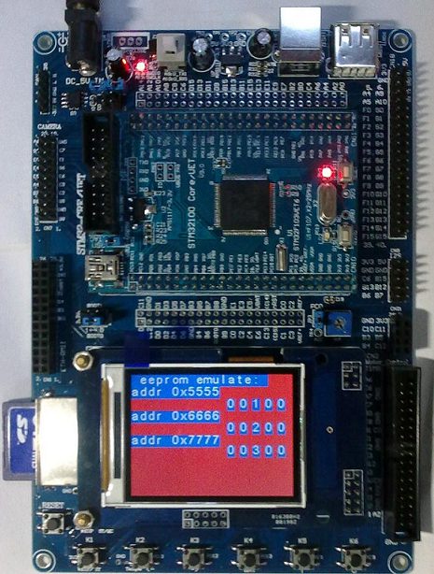
- MCU: STM32F373VCT6 (100pin)
- Core work at up to 72M frequency
- 256KB Flash and 32KB RAM
- USB Device、SDIO interface
- l 2.4’ TFT LCD
- 1 CAN channel port
- 4 User Leds, 6 User Keys
- 1 Power Key, 1 Reset Key
- 1 Power Led
- 1 DV 5V power interface
- 1 I2C EEPROM 24C02
- 1 SPI FLASH AT45DB161
- 1 AD channel with Pointer
- l RTC with backup battery interface
- l JTAG Debug port
- l ALL I/O expansion

Order NO: STM3237V-CRE/UET

System description：
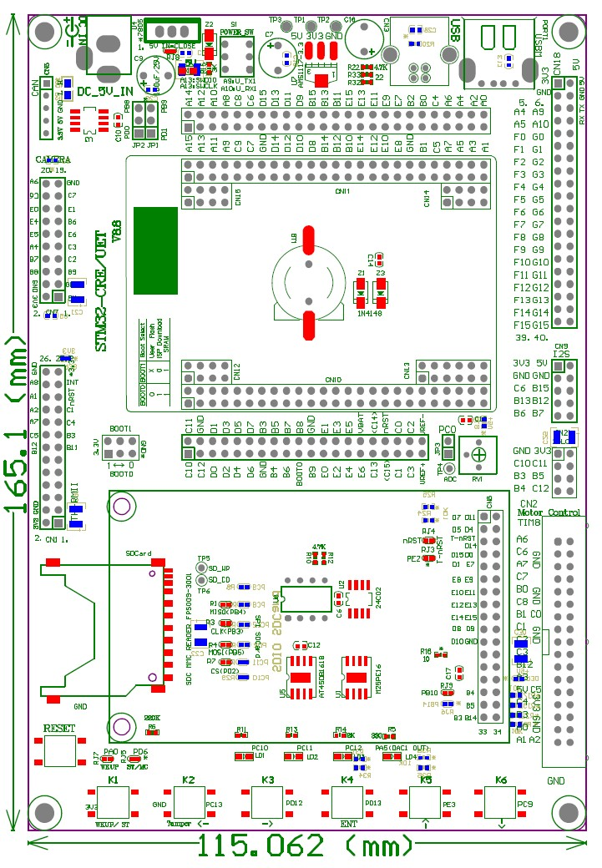
4 User Ledss
Reset Key
6 User Keys
2.4
TFT LCD

SPI or SDIO interface
SPI Flash
AT45DB/M25P
I2S interface
Boot SW Jump
DC 5V IN
Camera for F2/F4 CPU
Ethernet for F2/F4/F107
ADC Pointer
CAN chip
CAN interface
24L01 CN
DIP/SOP
MC control
interface

nRF24L01
interface
Part GPIOs
Back-up
Battery
STM32F373VCT6
CORE BOARD

Power Led
JTAG CN
Two kinds
Interface
Of USB

Power Key

U-easytech STM3237V-CRE/UET

STM3237V-CRE/UET 开发板

简介:
STM3237V-CRE/UET开发板是一块基于CORTEX-M4内核的STM32F373VCT6微处理器的开发平台。STM32F373VCT6 有2个I2C, 2个SPI,3个USART,1路CAN,3个16位Sigma Delta ADC转换器，1个12位ADC转换器，3个12位DAC转换器，内部有32KB SRAM, 256KB FLASH,支持JTAG调试。此评估平台可作为用户应用开发时做参考，而未作最终产品应用考虑。用户可通过JTAG用STLINK或JLINK仿真下载程序。

特点:
- CPU:STM32F373VCT6 (100pin)
- 最大工作频率：72M
- 256K FLASH,32K RAM
- 具有USB 从设备接口和SDIO接口
- 一个2.4 TFT 液晶
- 一路CAN通道接口
- 4个用户指示灯，6个用户按键
- 1个电源开关，一个复位键
- 一个电源指示灯
- 一个DV5V输入接口
- 一个24C02 存储芯片
- 一个SPI FLASH存储芯片AT45DB161
- 一个AD电位器
- 电池接口
- 一个JTAG口
- 所有IO引出

订单编号: STM3237V-CRE/UET

